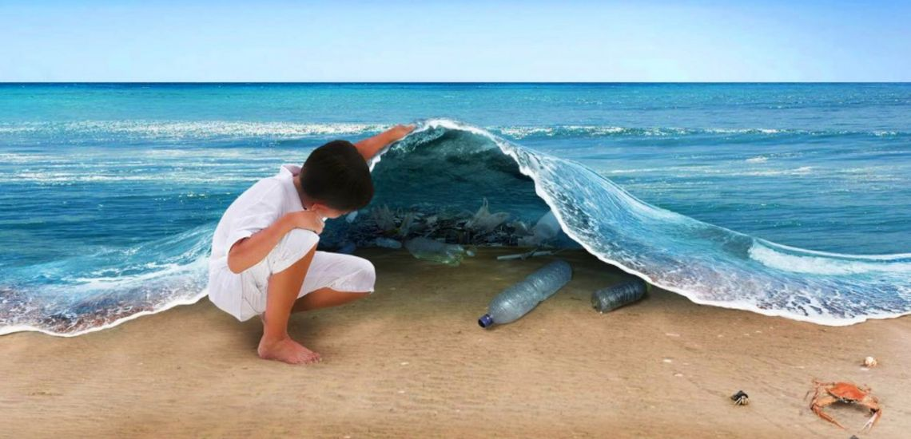

Clear Blue Clean Up Events
2021

DATE/TIME | BEACH | LOCATION
01/15/2021@8:30am | Thousand Steps Beach | Laguna Beach, CA
02/15/2021 @8:30am | Carlsbad State Beach | Carlsbad, CA
03/15/2021@8:30am | Dog Beach | Ocean Beach, CA
04/15/2021@8:30am | Glass Beach | Fort Bragg, CA
05/15/2021@8:30am | La Jolla Cove | La Jolla, CA
06/15/2021@8:30am | Cama Beach State Beach | Camano Island, WA
07/15/2021@8:30am | Cape Disappointment State Beach | Iiwaco, WA
08/15/2021@8:30am | Fort Worden | Port Townsend, WA
09/15/2021@8:30am | Jetty Island Park | Everett, WA
10/15/2021@8:30am | Horsfall Beach Campground | North Bend, OR
11/15/2021@8:30am | Cannon Beach | Cannon Beach, OR
12/15/2021@8:30am | Ipanema Beach | Rio de Janeiro, Brazil

***Just Follow the signs to our location at each of these beaches. We look forward to seeing you here. We will provide water coolers and biodegradable cups. We will also provide all supplies for clean up efforts. All travel and food are the responsibility of the volunteers and will not be covered by Clear Blue.*****

